

School of Computer Science Engineering and Information Systems

Winter Semester 2025-2026

Department of Information Technology

BITE498J – Project – II

Review -1
QuerylessDB: AI Driven Database Retrieval System

22BIT0603- Aayush Saraf
Under the Guidance of
Dr. SWARNA PRIYA R.M
Designation: Professor Grade 1
SCORE

Guide Signature with date
Dr. Swarna Priya R.M
ABSTRACT:

With the rapid growth of data across domains such as e-commerce, healthcare, education, and business analytics, the need for efficient and user-friendly data access mechanisms has become increasingly important. Traditional database systems require users to possess technical knowledge of query languages such as SQL or MongoDB query syntax, which limits data accessibility for non-technical users. This project presents the design and implementation of an intelligent AI-based system that enables users to interact with structured databases using natural language queries.
The proposed system leverages large language models (LLMs) and natural language processing techniques to perform intent recognition, entity extraction, and dynamic query generation. User queries expressed in everyday language are analyzed to identify the underlying intent and relevant parameters, which are then mapped to appropriate MongoDB collections and fields. The system dynamically generates and executes MongoDB queries without relying on predefined templates, allowing it to handle a wide variety of user requests.
The backend of the system is developed using FastAPI to ensure low latency, scalability, and efficient API communication, while MongoDB is used for flexible schema design and fast data access. An optional web-based frontend built using React provides an interactive interface for users to view responses in multiple formats, including plain text, structured tables, and graphical visualizations. Agent-based reasoning frameworks such as LangChain and LangGraph are employed to orchestrate query processing workflows and improve system adaptability.
The results demonstrate that the proposed approach significantly simplifies database interaction by bridging the gap between human language and structured data systems. The system proves to be flexible, scalable, and applicable across multiple domains, making it a practical solution for intuitive data exploration and decision-making.

INTRODUCTION:
In the modern digital era, vast amounts of structured data are generated and stored across domains such as e-commerce, healthcare, education, and business analytics. While database management systems are highly efficient in handling this data, interacting with them typically requires technical knowledge of query languages like SQL or MongoDB syntax. This creates a significant barrier for non-technical users, who often know what information they need but are unable to retrieve it directly, leading to dependence on developers or predefined dashboards and slowing down data-driven decision-making.
Recent advances in artificial intelligence and natural language processing have made it possible to reduce this gap between human language and structured data systems. Large language models enable systems to understand user intent, extract relevant entities, and interpret context from natural language queries. These capabilities allow user queries expressed in everyday language to be translated into structured database operations, eliminating the need for users to learn complex query syntax and making data access more intuitive and efficient.
This project presents the design and implementation of an AI-based natural language interface for querying structured databases. The system dynamically converts user queries into executable MongoDB queries using intent recognition and agent-based reasoning. FastAPI is used to build a scalable backend, while MongoDB provides flexible and efficient data storage. An optional React-based frontend allows results to be presented in text, tabular, or visual formats. The proposed system demonstrates how intelligent natural language interfaces can simplify database interaction and improve accessibility across multiple application domains.

PROBLEM STATEMENT:
The main problem addressed by this project is the difficulty non-technical users face when interacting with structured databases. Although databases store valuable information, accessing this data requires knowledge of query languages such as SQL or MongoDB syntax. As a result, users must rely on technical experts or predefined dashboards even for simple queries, which leads to delays, increased workload, and inefficient use of data. There is a need for an intelligent and intuitive system that can understand natural language queries, accurately identify user intent, and automatically convert those queries into database operations, enabling faster and more accessible data retrieval.
OBJECTIVES:
The objective of this project is to design and implement an intelligent AI-based system that allows users to interact with structured databases using natural language queries. The system aims to understand user intent, extract relevant information from free-form text, and automatically generate and execute MongoDB queries without requiring users to have knowledge of database query languages. Additionally, the project focuses on providing accurate and user-friendly responses in multiple formats such as textual summaries, structured tables, and visualizations, while ensuring scalability, efficiency, and ease of use for non-technical users across various application domains.

SCOPE OF THE PROJECT:
The scope of this project includes the development of an AI-driven natural language interface that enables users to query structured MongoDB databases without requiring technical knowledge of query languages. The system covers end-to-end functionality, including intent recognition, dynamic query generation, backend API processing, and optional frontend visualization. The project is designed to support multiple application domains such as e-commerce, education, healthcare, and business analytics, while remaining scalable and adaptable to evolving database schemas and user requirements.
PROPOSED SYSTEM:
The proposed system is an AI-based natural language interface that allows users to interact with structured databases using everyday language. It uses large language models to understand user intent, extract relevant parameters, and dynamically generate MongoDB queries. The system is built with a FastAPI backend for efficient request handling, MongoDB for flexible data storage, and an optional React frontend to display results in text, table, or visual formats, providing an intuitive and efficient data access solution for non-technical users.

LITERATURE SURVEY:

Title | Merits | Demerits / Limitations
A Natural Language Interface for Querying Structured Databases Using Deep Learning (Chen et al., 2022) | Demonstrates effective use of deep learning for translating natural language queries into structured database operations. Validates feasibility of NLP-driven database interaction. | Focuses mainly on relational databases and lacks dynamic schema handling and agent-based reasoning. Limited discussion on real-time scalability and UI visualization.
Enhancing Intent Detection in Dialogue Systems with Contextual Embeddings (Li et al., 2021) | Improves intent recognition accuracy using contextual embeddings, which supports reliable intent extraction in natural language queries. | Concentrates on dialogue systems rather than direct database query generation. Does not address backend query execution or schema mapping.
Know What You Don’t Know: Unanswerable Questions for SQuAD (Rajpurkar et al., 2018) | Introduces robustness in handling ambiguous or unanswerable queries, helping prevent incorrect or misleading responses in AI systems. | Oriented toward reading comprehension tasks, not database querying. Does not contribute directly to query formulation or execution logic.
Neural Approaches to Conversational AI (Gao et al., 2019) | Provides a comprehensive survey of neural conversational models, forming the conceptual foundation for AI-driven user interaction. | Survey-based and theoretical; does not provide direct implementation strategies for database-driven conversational systems.
Design and Implementation of RESTful APIs for Efficient Data Retrieval Using FastAPI and MongoDB (Das & Kumar, 2020) | Supports the architectural choice of FastAPI and MongoDB for efficient backend development and API communication. | Does not integrate AI or NLP components. Limited to traditional request–response data retrieval.
End-to-End LSTM-based Dialog Control Optimized with Supervised and Reinforcement Learning (Williams & Zweig, 2016) | Early end-to-end dialog modeling approach useful for understanding conversational flow and decision control. | Uses LSTM architectures, which are less effective than transformer-based models used in modern NLP systems.
Constructing an Interactive Natural Language Interface for Relational Databases (Li & Jagadish, 2014) | Foundational work in NL-to-database interfaces. Highlights challenges in mapping language to structured queries. | Limited to relational databases and rule-based techniques. Lacks adaptability and learning-based intent recognition.
Natural Language Interfaces to Databases – An Introduction (Androutsopoulos et al., 1995) | Provides early theoretical insights and taxonomy of NLIDB systems, useful for background understanding. | Outdated approaches with no deep learning or modern NLP techniques. Not suitable for large-scale or dynamic data.
LangChain Documentation | Enables modular prompt chaining, intent detection, and integration with LLMs, directly supporting AI-driven query generation. | Performance depends on prompt design and underlying LLM quality. Limited native database schema awareness.
LangGraph Documentation | Facilitates agent-based reasoning and structured decision flows, enhancing scalability and flexibility of query execution. | Adds architectural complexity and requires careful orchestration for production-grade systems.
An Introduction to Multi-Agent Systems (Wooldridge, 2009) | Provides academic foundation for agent-based workflows used in intent processing and decision-making. | Conceptual and theoretical; does not provide direct implementation details for modern AI frameworks.

SYSTEM ARCHITECTURE:
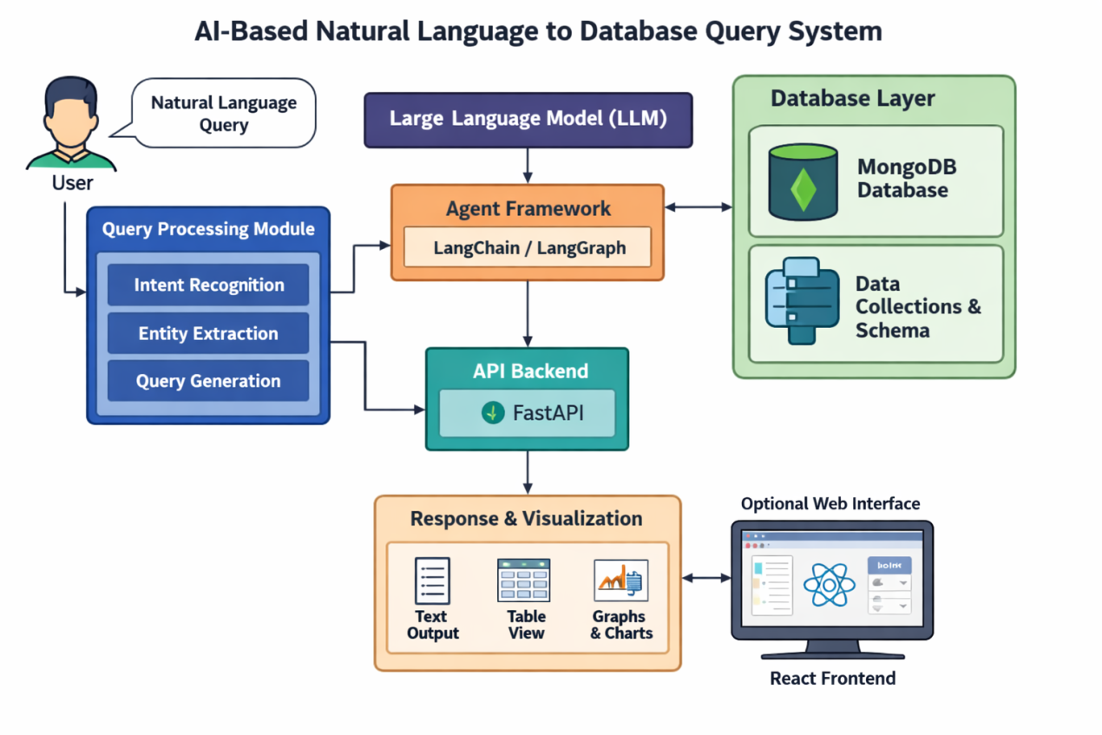

REFERENCES:

[1] L. Chen, H. Xu, and Y. Zhang, “A natural language interface for querying structured databases using deep learning,” IEEE Access, vol. 10, pp. 13249–13262, 2022, doi: 10.1109/ACCESS.2022.3147049.
[2] Z. Li, T. Sun, and K. Liu, “Enhancing intent detection in dialogue systems with contextual embeddings,” in Proceedings of the 59th Annual Meeting of the Association for Computational Linguistics (ACL), 2021, pp. 4928–4938, doi: 10.18653/v1/2021.acl-long.381.
[3] P. Rajpurkar, R. Jia, and P. Liang, “Know what you don’t know: Unanswerable questions for SQuAD,” in Proceedings of the 56th Annual Meeting of the Association for Computational Linguistics (ACL), 2018, pp. 784–789, doi: 10.18653/v1/P18-2124.
[4] J. Gao, M. Galley, and L. Li, “Neural approaches to conversational AI,” Foundations and Trends in Information Retrieval, vol. 13, no. 2–3, pp. 127–298, 2019, doi: 10.1561/1500000074.
[5] A. Das and S. Kumar, “Design and implementation of RESTful APIs for efficient data retrieval using FastAPI and MongoDB,” International Journal of Computer Applications, vol. 176, no. 33, pp. 15–21, 2020, doi: 10.5120/ijca2020920053.
[6] J. D. Williams and G. Zweig, “End-to-end LSTM-based dialog control optimized with supervised and reinforcement learning,” arXiv preprint, arXiv:1606.01269, 2016. [Online]. Available: https://arxiv.org/abs/1606.01269
[7] F. Li and H. V. Jagadish, “Constructing an interactive natural language interface for relational databases,” in Proceedings of the VLDB Endowment, vol. 8, no. 1, pp. 73–84, 2014.
[8] I. Androutsopoulos, G. Ritchie, and P. Thanisch, “Natural language interfaces to databases – An introduction,” Natural Language Engineering, vol. 1, no. 1, pp. 29–81, 1995.
[9] LangChain, “LangChain Documentation,” 2024. [Online]. Available: https://python.langchain.com/docs/
[10] LangGraph, “LangGraph Documentation,” 2024. [Online]. Available: https://langchain-ai.github.io/langgraph/
[11] M. Wooldridge, An Introduction to Multi-Agent Systems, 2nd ed. Chichester, UK: John Wiley & Sons, 2009.

